EDIFY: CRITICAL NEXUS: TWITTER, WSGR, MACGILLIVRAY & WHITE HOUSE

15 September 2022|COVID-19, EDIFY INTEL

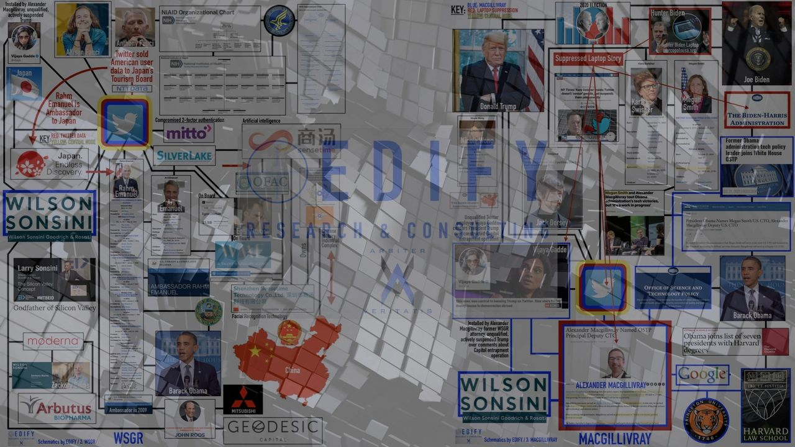

**15 SEP 22 / MONTANA, USA**

**PRIMARY SUBJECTS: Wilson Sonsini Goodrich & Rosati, Twitter, Biden White House, Obama White House, James Baker, Alexander Macgillivray, Vijaya Gadde**

In conjunction with a client who remains confidential, EDIFY developed the nexus schematics featured in this brief that are well-evidenced and identify and connect a slate of important individuals, entities and nations respective to a wide swath of past and ongoing scandals, corruption, crime, treason and bioterrorism.

This brief serves to expand and back-fill the details of the featured graphics while providing meaning with some granularity. At the same time, it informs important ongoing matters and litigation.

**The findings develop along six vectors** to demonstrate how the entanglements, relationships and overlaps translate to an effective network. The network is positioned to impact important matters like COVID-19 and the Hunter Biden laptop story as just two examples and whereby Twitter's censorship of both makes **Twitter the central node**.

The **six vectors** are: **1-Twitter**, its censorship policies and the application and enforcement thereof, **2-Wilson Sonsini Goodrich & Rosati [WSGR]** an international law firm with over 1,000 attorneys representing many of the world's largest corporations, as a hub with spokes running to critically-positioned individuals that is suggestive of WSGR as an interface for political control and influence across a wide array of Big Tech and geopolitical domains, **3- Alexander Macgillivray** as a WSGR product who serves in the critical position of Principal Deputy U.S. Chief Technology Officer for the Biden Administration and who served the Obama White House similarly, **4-Vijaya Gadde** as a WSGR product who was installed by Macgillivray at Twitter when Macgillivray served as Twitter's General Counsel and where Gadde went on to suspend President Donald Trump, **5-Former FBI General Counsel James Baker** as a common thread through Twitter to President Trump and the FBI/DOJ FISA abuse against Trump and **6-Alison Fauci,**Dr. Anthony Fauci's daughter,as a Twitter engineer and Twitter's overlap to and potential communication and intelligence conduit for the COVID-19 enterprise fraud construct via Anthony Fauci and his NIH interface.

In the featured **nexus schematics,** the six vectors above are examined with **explanations** and **SUMMARY FINDINGS** to follow:

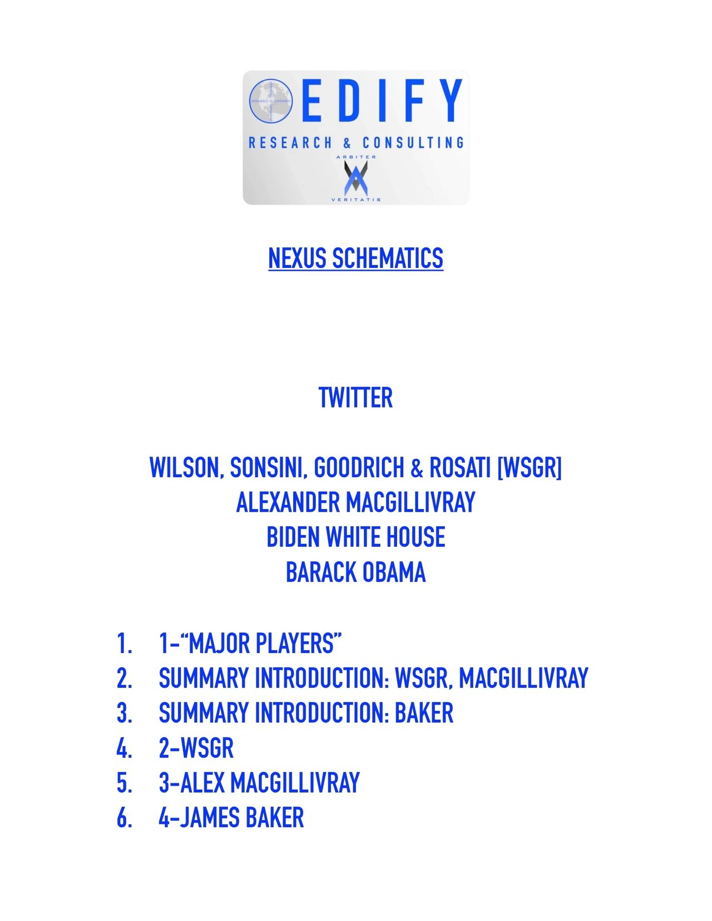COVER PAGE

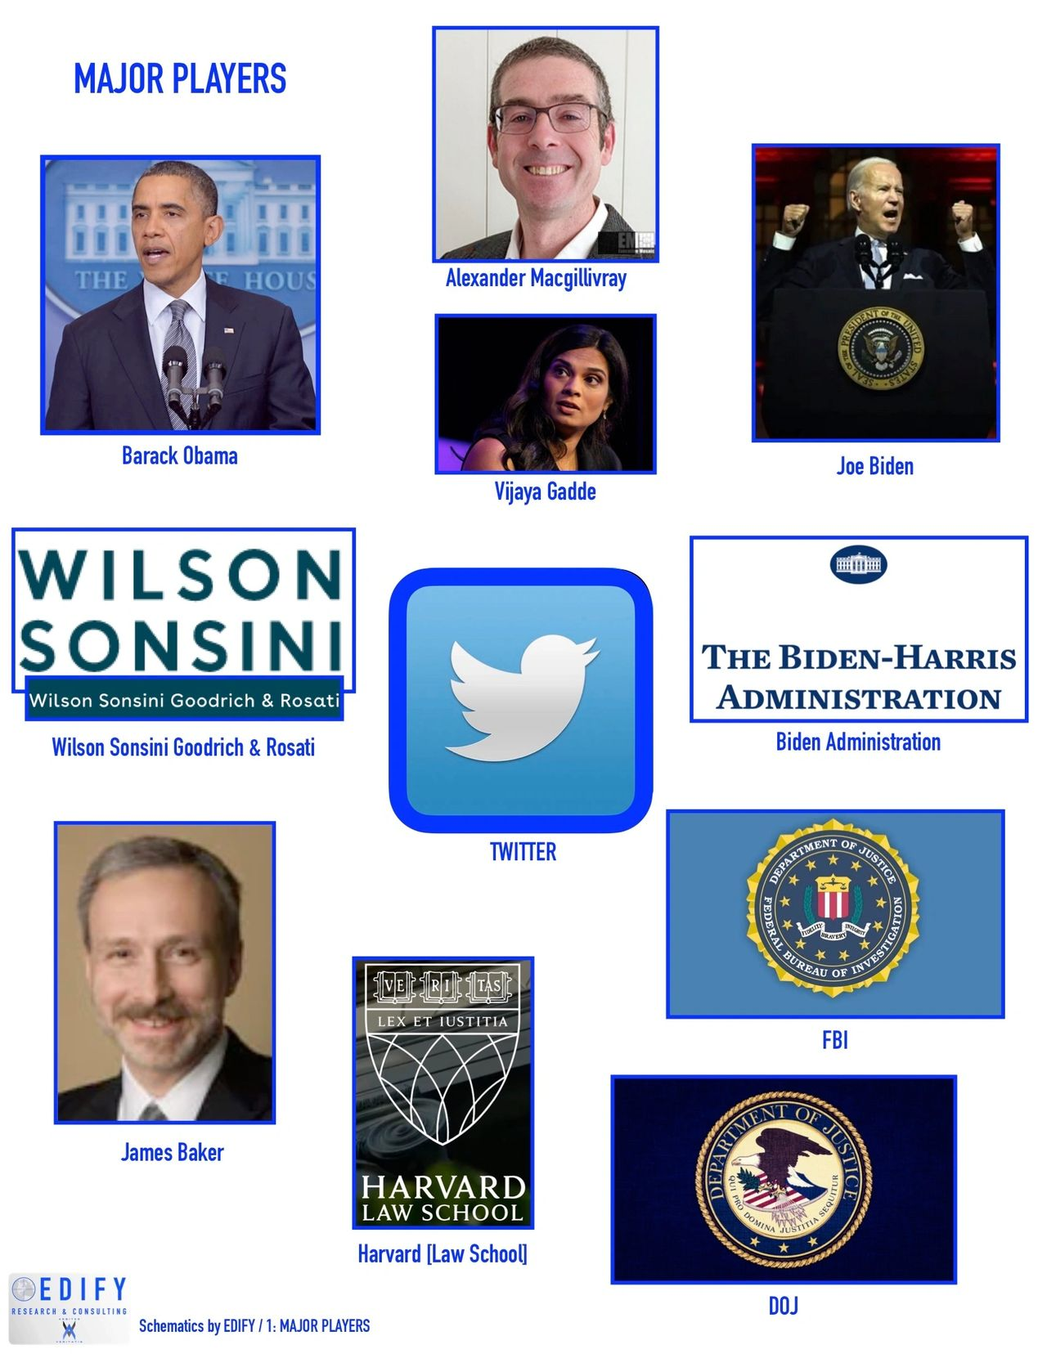MAJOR PLAYERS

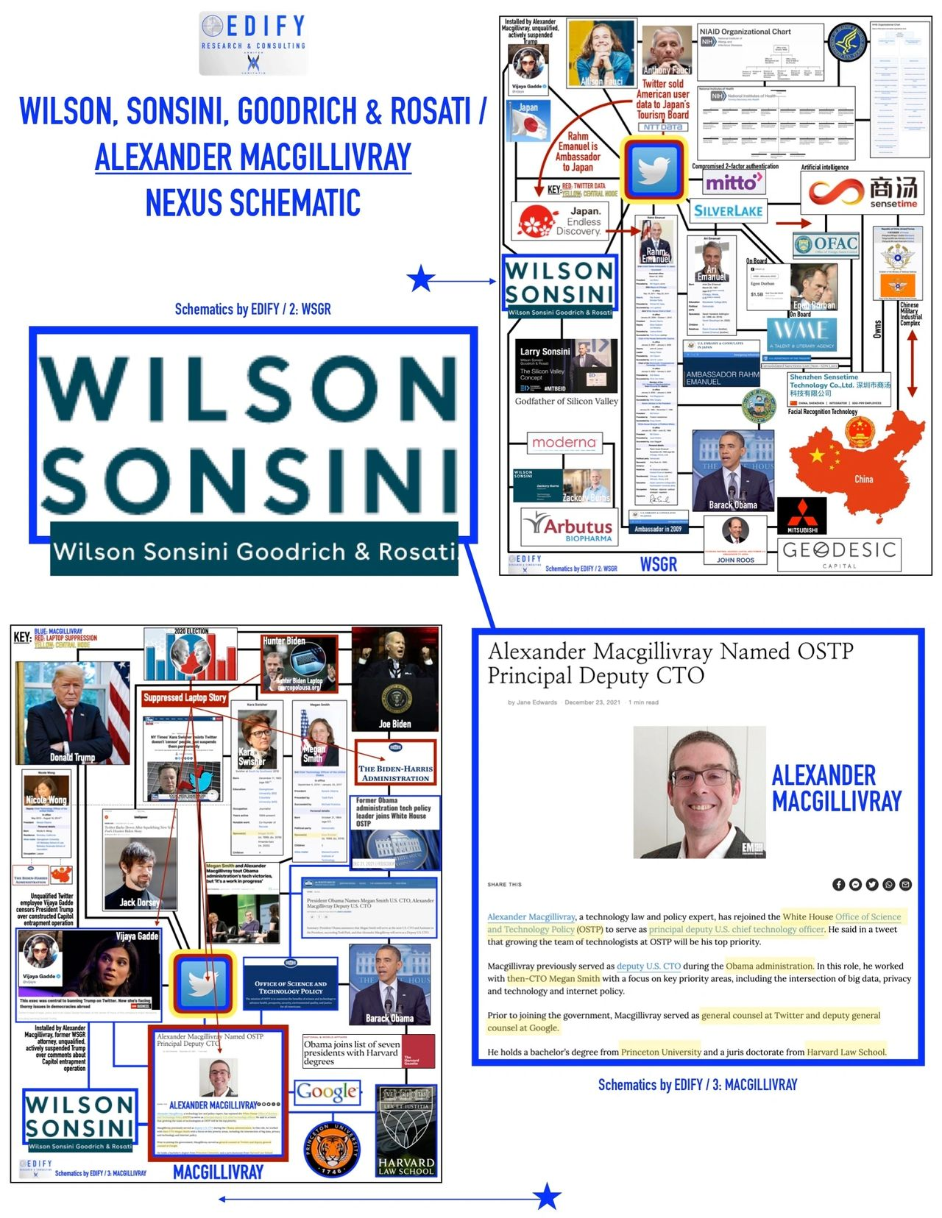SUMMARY INTRODUCTION: WSGR, MACGILLIVRAY

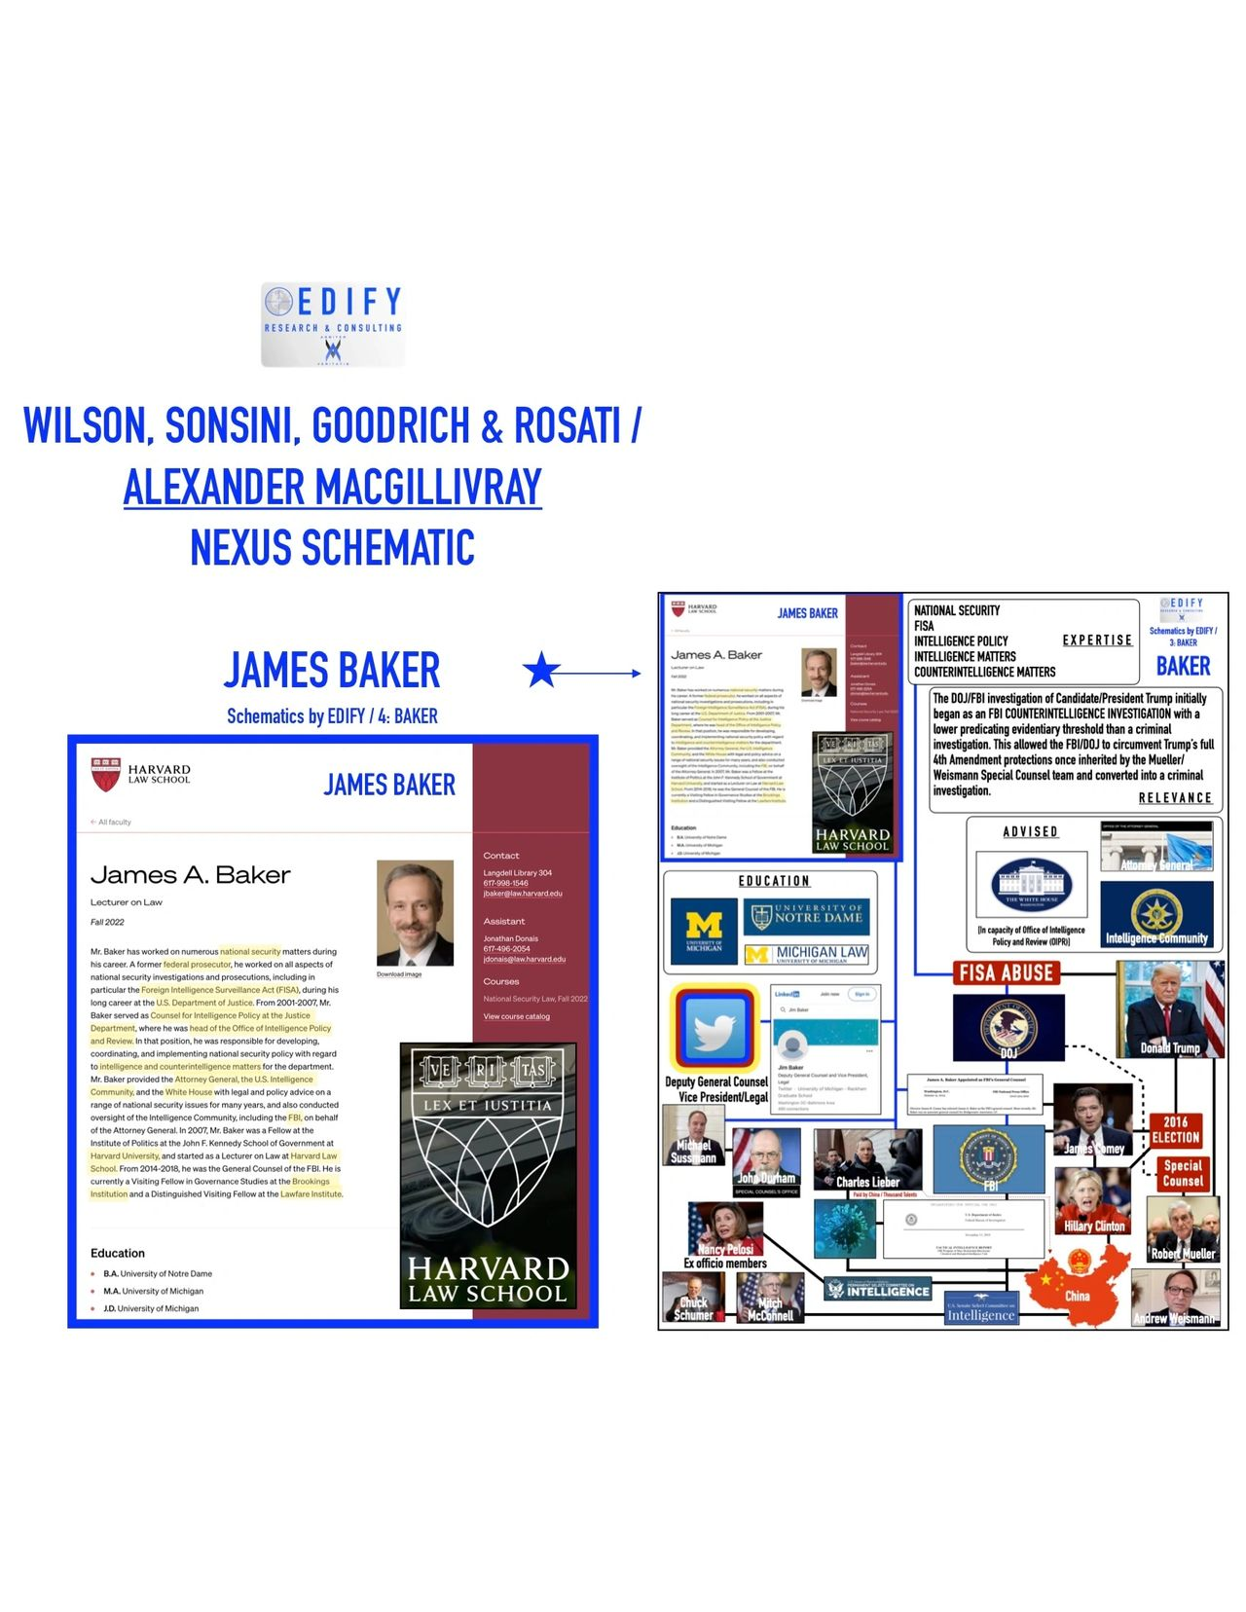SUMMARY INTRODUCTION: BAKER

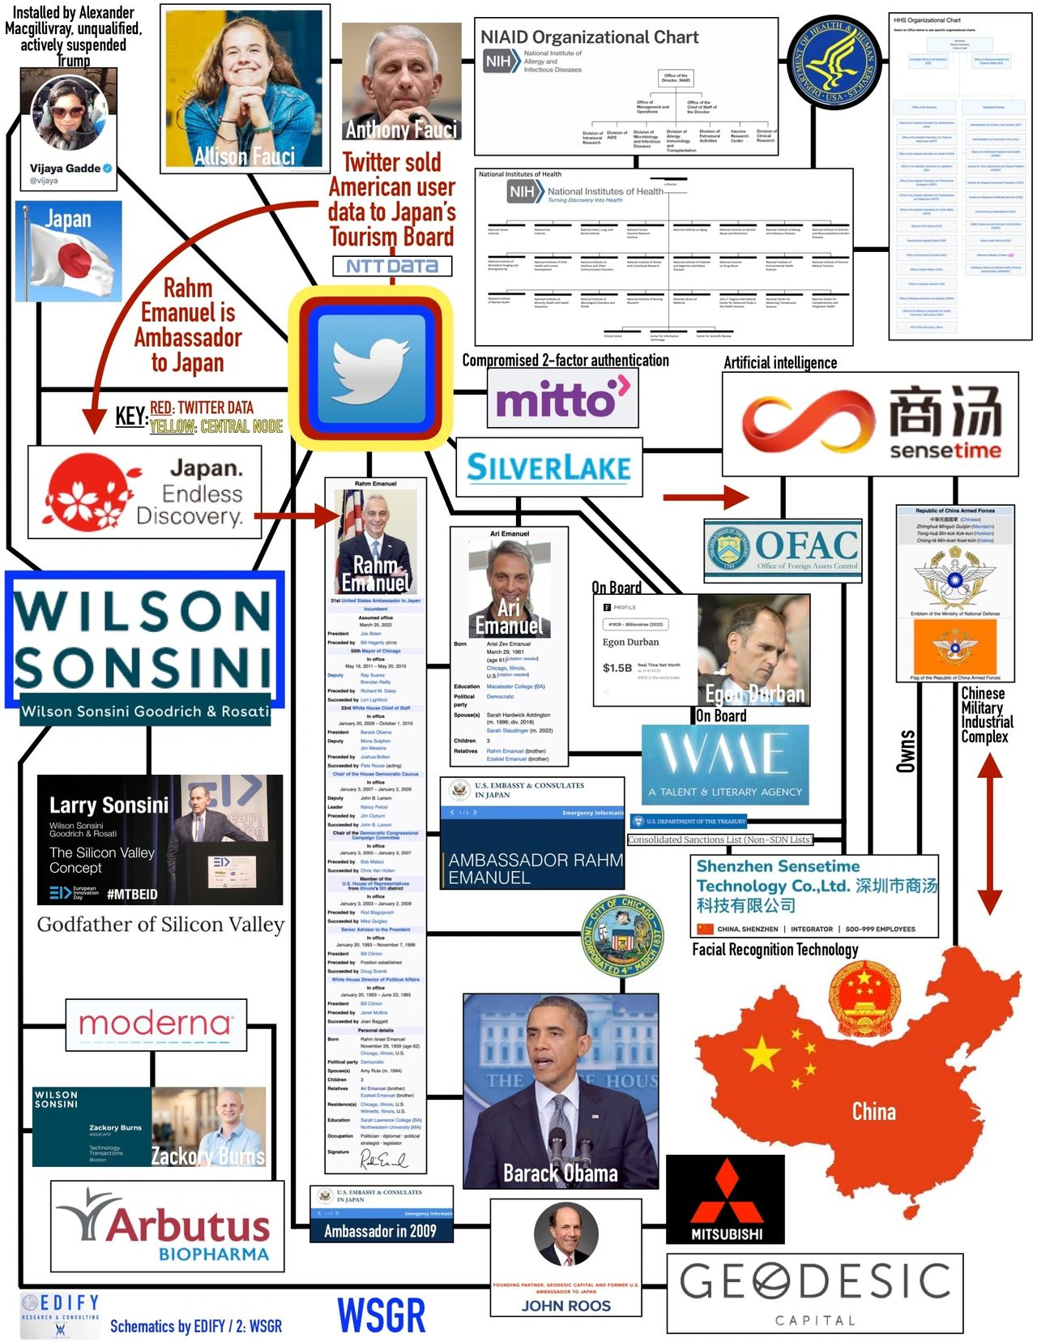PRIMARY SUBJECT: WSGR

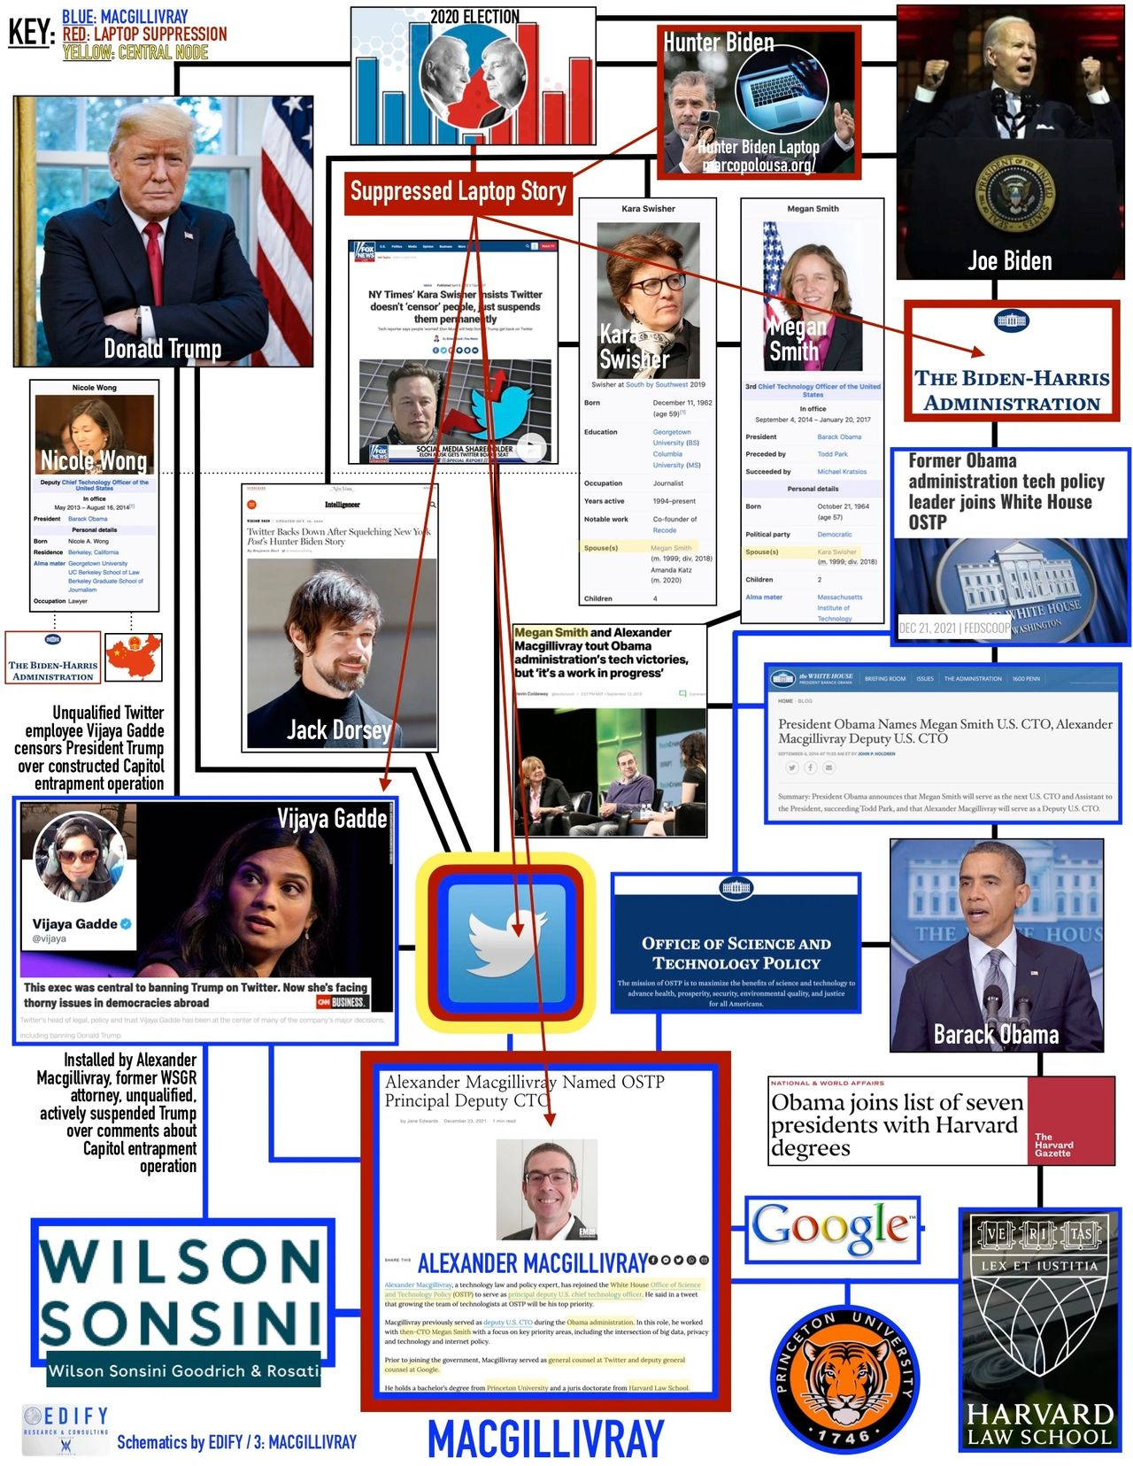PRIMARY SUBJECT: MACGILLIVRAY

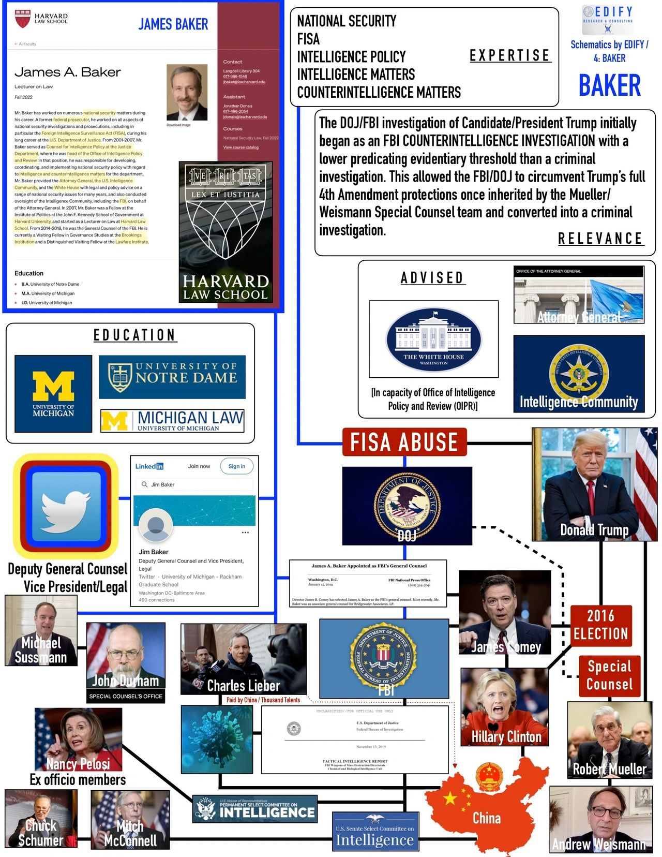PRIMARY SUBJECT: BAKER

**VECTOR 1:** **TWITTER:** **Twitter is the central node and the keystone to understanding**. Twitter's inherent value to the elites, political class and federal apparatus writ large is found in its ability to engage in **perception management**, which is a technical term more commonly referred to as "psyops" or "psychological warfare". [1] [2] [3] [4] [5]

Twitter engages in perception management in its capacity to establish and manipulate reality by means of actively determining and shaping the content on its platform. [1] [2] [3] [4] [5] Twitter consumers can receive filtered content or are prevented from receiving, seeing or having the ability to publish content altogether. [1] [2] [3] [4] [5]

**The de facto censorship occurs primarily along the lines of determining and enforcing community standards, guidelines and rules for user engagement**. [1] [2] [3] [4] [5] The evidence is clear that the decisions here appear to fall along clearly identifiable political lines resembling two-tier justice. [1] [2] [3] [4] [5]

Content determination, algorithmic manipulation and politically motivated censorship of off-reservation messaging and political opposition are all evidenced examples of how Twitter engages in perception management or appears to do so. [1] [2] [3] [4] [5]

Two evidenced domains of Twitter's engagement in perception management include censoring content relative to COVID-19 [6] [7] [8] [9] [10] and the Hunter Biden Laptop story. [11] [12] [13] [14] [15] [16] [17] [18] [19] [20] [21]

Problematic for the critics of Twitter as a politically aligned entity is the patterned evidence of primary subject and other individuals being directly and indirectly tied to other relevant and important individuals and entities in overlapping domains. The complexity is high and so the schematic illustrations are hugely beneficial for understanding.

These nexuses occur such that clear and identifiable alignment to strict political agendas is found on one side of the political spectrum, where censorship is rampant, but not on the other side, where content is essentially unimpeded.

**Summarily, evidence and analysis positions Twitter as a gatekeeper of public information.**

Evidence of Twitter's gatekeeper designation is found threaded through **Wilson Sonsini Goodrich & Rosati as an interface for directly impacting the geopolitical landscape**andrising to the level of affecting significant change. [22]

**The primary subject from WSGR is Alexander Macgillivray.** [22] [23]

**VECTOR 2:** **WILSON SONSINI GOODRICH & ROSATI:** WSGR is a an international law firm with over 1,000 attorneys representing many of the world's largest corporations. WSGR is a primary thread through the network being evidenced that strings directly through to the primary node, Twitter. In that light, **WSGR represents Twitter in all corporate disclosures.**[24] [25] [26]

In regard to Macgillivray, **WSGR also previously employed Vijaya Gadde**, who was subsequently **installed at Twitter by Macgillivray** during his tenure there as General Counsel. [27] **Gadde was central to Twitter's censoring, suspension and banishment of President Donald Trump from the platform.** [28]

**WSGR's representation directly overlays COVID-19 in a very critical capacity.** **WSGR represents** **Arbutus Biopharma Corp.**, a Canadian company that is one of two **patent holders for U.S. Patent Nos. 8,058,069 and 9,364,435,**which are the **two patents for the lipid nanoparticle envelope necessary to manufacture the COVID-19 mRNA "vaccines".** [29] [30] [31]

An underlying position holds that the initial phases of the COVID-19 enterprise fraud construct included the unsustainable phase of comorbidity data harvesting where other morbidities [flu/pneumo, heart disease, diabetes and pneumonia] were fraudulently curated and then propagated as COVID-19/SARS-COV-2.

The subsequent "pandemic" phase is one of the vaccinated and boosted. **This phase is entirely dependent upon acquiring the patent rights to the mechanism required to deliver the mRNA payload in the injection**. The mRNA injections leverage the reverse transcription process causing the recipients' DNA to become altered to the extent that it causes the body to begin producing the known and problematic S1 spike protein on its own. Evidence indicates that infection and mortality data for COVID-19 currently represents a "pandemic" of the "vaccinated" and boosted. [32] [33] [34] [35]

**If vaccine manufactures didn't acquire rights to WSGR-represented Arbutus' patents, there could be no "pandemic", for there would be no delivery mechanism for the required mRNA payload.** [36]

With **evidence linking COVID-19 directly to China and the Wuhan Institute of Virology, WSGR may further overlay China by its representation of SolarWinds.** [37]SolarWinds was directly hacked in a sprawling data breach that caused U.S. lawmakers to designate a national emergency in 2020. China is suspected of the attack and if true, accounts for the overlay.[38] [39] [40] [41]

Relative to the**sale of American user Twitter data to Japan's Tourism Board through NTT Data,**a Japanese company;and as it enmeshes Silver Lake Capital,**WSGR represents Twitter in its partnership with Silver Lake.**[42] [43] [44] [45] [46] [47] [48]

**Silver Lake connects to Ari Emanuel and positions Emanuel as a possible intermediary and conduit from the Biden/Obama cartel to the Japan Tourism Board through another possible and connected conduit/intermediary Rahm Emanuel, the current Ambassador to Japan.**[49] [50] [51]

**Silver Lake is linked to artificial intelligence and facial recognition companies in Sensetime and Shenzhen Sensetime Technology Co. Ltd. including Silver Lake CEO Egon Durban, who is on Twitter's Board of Directors.**Durban is also on the board at WWE, where Ari Emanuel is CEO. Silver Lake has a 20% stake in Sensetime and Shenzhen Sensetime Technology Co. Ltd.

**Those companies are CCP functionaries and it is suspected that the Twitter data is being leveraged by them to develop profiles that could be used for China to target American citizens.**[52] [53] [54] [55] [56] [57]

**VECTOR 3: MACGILLIVRAY:** **Alexander Macgillivray is the primary subject linking multiple individuals, entities and events** including but not limited to **WSGR, Twitter, the censorship of President Trump, President Barack Obama, President Joe Biden and the Office of Science and Technology Policy and Google.** [23]

**WSGR employed attorney Alexander Macgillivray who links Twitter and WSGR to the Obama and Biden Administrations in critical roles**, respectively: 1-Deputy U.S. Chief Technology Officer, Office of Science and Technology Policy [OSTP] and 2-Principal Deputy U.S. Chief Technology Officer, Office of Science and Technology Policy [OSTP]. [58] [59] [60] [61] [62]

Prior to serving the Obama and Biden White Houses, **Macgillivray served as General Counsel to Twitter and Deputy General Counsel to Google.**[63] Between the two administrative terms and according to his own blog, Macgillivray installed the CTO at the DNC and worked on election data. [70]

**The sequenced thread of Macgillivray from WSGR to Obama to Twitter to Google to Biden is critical to understanding and presents as a launch point for fulsome comprehension of the full network.**

**Macgillivray currently serves the Biden White House OSTP as the Principal Deputy U.S. CTO.** [59]

Established as a primary gatekeeper of public information, **Twitter would likely require an interface with the federal government and presidential administration[s]** to align Twitter with on-reservation messaging as the evidence suggests. For Twitter, this necessitates content determination, algorithmic manipulation and politically motivated censorship of off-reservation messaging, which have been widely reported. [1] [2] [3] [4] [5] Evidence suggests that **Macgillivray is a good candidate for that interface** through the OSTP in a familiar pattern of Obama retreads serving Biden in the same or similar capacities. It will be further evidenced relative to **Nicole Wong** below. [64]

As noted, during his tenure as **General Counsel for Twitter, Macgillivray installed Vijaya Gadde**, who was unprepared and unqualified in her position according to Macillivray's words. **Gadde was** **central to Twitter's censorship, suspension and banishment of President Trump from its platform.**[65]

**When Macgillivray exited Twitter, he only did so on official terms:** *"“I’ll continue to support the company and its great people by staying on  as an advisor for the legal, trust & safety, corporate development  and public policy teams,”* said Macgillivray. *“I continue to care deeply  about Twitter, the folks who work at Twitter and our tremendous users,  so I’ll remain close to all three.”"*[66]

From a ground floor perspective and in her multiple and similar capacities, **Chinese-American Nicole Wong appears to have set the course for Macgillivray's trajectory.** [67]  **Wong's trajectory cycled her through Twitter, Google and the Obama and Biden administrations.** [68] Wong served the Biden transition team as overlaid by the CTSO/CTO vectors. **Wong joined Biden's transition Agency Review Team** to support transition efforts related to the **National Security Council**and the **Office of Science and Technology Policy.**[69]

**Specifically, it is held that Wong likely returned to facilitate Macgillivray's transition into the Principal Deputy U.S. CTO position for the Biden White House.**

**The argument that Wong was the "first version" of Macgillivray respective to his roles and functions identified in this report, is further evidenced**by Wong's similar background, to which she returned, respective to the CTSO/CTO vectors as overlaid by the national security domain and the current Biden Administration. It presented as the veteran ushering in the less experienced player, so to speak.

Wong's professional entanglements also include but aren't limited to: Perkins Coie LLP [becoming partner], Georgetown University, Berkley School of Law and the Stonebridge Albright Group. [68]

**Macgillivray maintains a personal**[**blog**](https://www.bricoleur.org/) with many of his thoughts and opinions that are topical to matters here. [70]

**VECTOR 4: GADDE:** **Vijaya Gadde is a primary subject,** who is secondary to Macgillivray and **who was installed as Twitter's General Counsel by Macgillivray** when the latter departed the company. [27] **Vadde is generally regarded as unqualified and unprepared for her position respective to the scope of its duties** and this made **Gadde susceptible to manipulation by those surrounding her.**[66]This is according to Macgillivray. [65] It occurs along the lines of **Gadde appearing to be reliant on information and input from said others** to fully execute her duties.

Consider, *"Though Gadde doesn’t have the same bonafides as Macgillivray when it  comes to first amendment stuff, she is apparently regarded well in the  company and at her former firm.*

*In addition, from what we’ve  heard, Twitter will be doing some shuffling of the legal structure as  well. Its director of public policy Colin Crowell will no longer report  to the General Counsel, but will report directly to CEO Dick Costolo on  matters affecting Twitter and Washington."* [65]

In his Twitter departure, Macgillivray stated directly that he would continue to advise Gadde's department lending to **Macgillivray appearing as a prime interface for such manipulation** of Gadde to occur. [66]

**Gadde was formerly employed by WSGR** like Macgillivray. [71]

**Gadde was the primary subject who in the capacity of General Counsel for Twitter was central to the censorship, suspension and banishment of President Trump from Twitter's platform altogether while likely under the influence of others, such as possibly Macgillivray.** [72] [73] [74] [75]

**VECTOR 5: BAKER:** **Former FBI General Counsel James Baker is a primary subject** that threads top to bottom in varying capacities and overlaps. [76] [77] [78] Of particular interest to the matters here are his **affiliation with the orchestrated and widely reported broader attacks on President Trump** and Baker's **array of expertise relative to his affiliation with Twitter as Deputy General Counsel and Vice President Legal.** [79]

**Baker's Twitter capacity is of particular interest relative to the broader attacks against President Trump, his supporters and specifically as it relates to First Amendment rights and the censorship of conservative content** favorable to Trump and unfavorable to Democrats and Democratic candidates like Hillary Clinton and Joe Biden. Such instances are widely reported.

Baker's acumen in law is compounded by his **ties to the FBI, DOJ and Judiciary relative to Twitter** and it is problematic here. **Baker is uniquely positioned to be plausibly informative about potential DOJ investigations into Twitter for violations.** **Baker is uniquely positioned in alignment with a long list of individuals and entities that overlap in critical areas.** It's all reinforced by **Baker's spectrum of expertise: FISA, national security, intelligence policy, intelligence matters, counter intelligence matters, law enforcement, prosecution, investigation** and more. [80] [81]

**The initial DOJ/FBI investigation into President Trump** **diverged into numerous other contrived, orchestrated, planned, manufactured and executed events** like rampant FISA abuse, two fraudulently predicated impeachments, the Mueller Special Counsel, the Capitol "insurrection" entrapment operation, a fraudulent pandemic and stolen 2020 election. These, too, have been widely reported.

**Baker was appointed by then FBI Director James Comey**, who is known as a long time Clinton confidant and fixer. Comey is **intricately linked to the 2016** **election and then candidate Hillary Clinton** by means of the FBI's decision not to pursue charges against Clinton for her private and unsecured email server.

**The origins of the targeting of and abuses against Trump derived from Clinton's false allegations** that Trump and Russia were conspiring due to Trump's association with Alfa Bank. [81] The ties further extend to the FISA warrant against Carter Page and so on as is well documented and reported by many. [82] [83]

**Baker's exposure overlaps cause him to be a primary thread.**Beyond what is already outlined above, **Baker is attached to Special Counsel John Durham** by means of his involvement and testimony in **the Michael Sussmann trial**and the broader matters pertaining to it. [84] Also, **Baker is the target of a federal investigation for leaking.**[85]

**Baker's FBI and intelligence/counterintelligence experience should have made him an expert in China and yet China appeared to operate undeterred under the bureau's nose** and continues to do so.

Moreover, **Baker's position and qualifications should have positioned him to be privy to the actions of *ex officio* members of the HPSCI and SSCI respective to China**, which would further extend to **COVID-19**. This would include subjects such as House Speaker Nancy Pelosi, then Senate minority leader Chuck Schumer and then Senate Majority leader Mitch McConnell.

**Baker's prominent threading through to the Obama Administration, FBI and DOJ respective to his ties to Twitter, make him a candidate central to both Twitter [ongoing litigation] and the intelligence and FISA abuses against Trump.**

It's important to recall that **the DOJ/FBI investigation of Candidate/President Trump initially began as an FBI COUNTERINTELLIGENCE INVESTIGATION** with a **lower predicating evidentiary standard than a criminal investigation.** This allowed **the FBI/DOJ to circumvent Trump’s full 4th Amendment protections. The Mueller/Weissmann Special Counsel team therefore appeared to inherit the Trump counterintelligence investigation and then convert into a criminal investigation.**

**VECTOR 6: FAUCI:** **The involvement of Dr. Anthony Fauci respective to COVID-19 is assumed** moving forward and as resting on substantial existing evidence. Moreover, this document includes limited evidence respective to funding and as outlined.

In part, it is evidenced by the flow of federal dollars from the NIH/NIAID to the Wuhan Institute of Virology. The intermediary for the transaction, which pertained to the funding of the bioengineering of the SARS-CoV-2 virus, was Peter Daszak of EcoHealth Alliance. [86] [87]

The entire Fauci onion peels back in layers suitable for a volume of books and is to substantial and complex for this space. It is also already fully documented by this investigator in an underlying catalog of analysis and work. The assumptions made on Fauci here allow us to remain focused. Lastly, they are made along the lines of **COVID-19 being entirely a construct of enterprise fraud and where Anthony Fauci is a primary subject and realistic candidate as a primary criminal defendant.**

Anthony Fauci's daughter, **Alison Fauci, is of particular interest to these matters respective to her hiring as an engineer at Twitter.** [88] This is suggestive of **Alison Fauci potentially serving as a conduit between Twitter, its leadership and censorship practices, and the federal medical apparatus framed by HHS, NIH, NIAID, CDC, et al.**

**According to recent whistleblower testimony from Peiter “Mudge” Zatko,** whom Twitter hired in November 2020 to enhance cybersecurity and privacy at the company, **testified that Twitter engineers have essentially unfettered and virtually anonymous access permitted by weakness in oversight and security allowing them to access personal and private data from user accounts.** [89] It does this to the extent that it **could permit the extraction and sale of that data without notice to Twitter** as permitted by the oversight and security weaknesses.

Zatko also testified that **the FBI had previously warned Twitter that it had one or more foreign intelligence operatives on its payroll**. **Evidence indicates penetration of Twitter by India and China.** [89]

**Alison Fauci is a Twitter software engineer who by title, would possess the technical capabilities and access to function as outlined in the testimony.**

Beyond Alison Fauci's functionality as a conduit or intermediary for Dr. Anthony Fauci and his principals at the NIH/NIAID and up, **Alison Fauci is by title technically positioned to potentially extract private Twitter user data on designated people including political opposition. Any such extracted data could be fed back upstream to the Obama, Biden cartel et al.**

It's also further evidence of a distinct pattern of nepotism threading through all of these matters where spouses and children play critical roles determined by their placement into the broader construct.

**Alison Fauci was positioned to be a possible conduit of information in an intermediary fashion relative to the Anthony Fauci cohort and its preferences for Twitter's censorship policies for reliable COVID content damaging to the COVID construct of enterprise fraud and that official narrative.**

**SUMMARY FINDINGS:**

**The six vectors provide a plausible and evidenced network** as diagrammed schematically and expanded upon in this report. **The evidence examined and analysis of it inform the SUMMARY FINDINGS ranging from evidenced fact to positions of a high level of confidence:**

1. Twitter is a recognizable and identifiable as a gatekeeper of public information
2. Twitter operates in alignment with a strict political agenda
3. Twitter's agenda alignment appears along the lines of progressive liberal and Democrat thought and policy
4. Twitter's collective actions technically rise to the level of engagement in perception management
5. Twitter engagement in perception management includes content determination, algorithmic manipulation and apparent active censorship against off-reservation messaging [conservative content favorable to Trump]
6. WSGR represents Twitter in all of its corporate disclosures making WSGR integral to all things
7. WSGR partner Larry Sonsini is regarded as the "Godfather of Silicon Valley" [90]
8. WSGR employed Alexander Macgillivray, another Harvard Law product, who went on to become an apparent architect for censorship practices while serving that capacity in the Obama and Biden White Houses
9. WSGR has critical ties to factually inconvenient individuals and entities such as Arbutus, Moderna and the mRNA vaccines vis-a-vis Arbutus' patent holdings on the lipid nanoparticle envelope
10. WSGR is involved in ongoing litigation respective to the previous point
11. WSGR is indirectly positioned to intersect two presidential administrations in a capacity to target a third: Obama and Biden; targeting Trump
12. WSGR presents as an international firm capable of directly impacting the U.S. geopolitical landscape and media content on social media platforms
13. Macgillivray is the primary subject threading WSGR to the Obama and Biden Administrations and Twitter according to evidence
14. Macgillivray's affiliations with/as WSGR, Twitter, Harvard Law, OSTP, U.S. CTO, Google and Vijaya Gadde are problematic
15. Macgillivray's highly partisan and biased positions manifesting as anti-Trump are detailed by his own admission in his own blog
16. Macgillivray installed another WSGR asset in Vijaya Gadde to succeed him as General Counsel
17. Gadde was born in India and immigrated to the U.S. at three years of age
18. Vijaya Gadde was unqualified and was subject to influence by others including Macgillivray in his unofficial capacity, so as to rely upon them to fully execute her duties as Twitter's General Counsel
19. As such, Vijaya Gadde was central to the censorship, suspension and banishment altogether from Twitter's platform
20. Gadde was central to Twitter's censorship of the Hunter Biden laptop story
21. Through NTT Data, Twitter sold American user data to Japan's Tourism Board
22. Long-time Barack Obama confidant Rahm Emanuel is the Ambassador to Japan
23. Emanuel's brother Ari Emanuel is another Obama confidant who attaches to Silver Lake Capital
24. Silver Lake Capital ties to Twitter and links Twitter, Obama and both Emanuel brothers through Ari Emanuel
25. Silver Lake Capital ties to Chinese company Sensetime, which specializes in artificial intelligence
26. Egon Durban, on WWE's board where Ari Emanuel is CEO, presents a likely bridge to full circle respective to China's acquisition of American Twitter user data
27. Durban bridge consists of his 20% stake in Sensetime and Shenzhen Sensetime Technology Co. Ltd and his membership on Twitter's Board of Directors
28. WSGR represents Twitter in its partnership with Silver Lake
29. Sensetime is affiliated with the Chinese Military Industrial Complex and the nation of China/CCP
30. SenseTime owns Shenzhen Sensetime Technology Co., Ltd., which specializes in Facial Recognition Techology
31. Shenzhen Sensetime Technology Co., Ltd. appears on the U.S. Treasury Department's "Consolidated Sanctions List" and through ownership ties to the Chinese Military Industrial Complex and the nation of China/CCP
32. Twitter's American user data sale to Japan/NTT is believed to have been funneled to China, the CCP and the Chinese Military Industrial Complex through the evidenced conduit network [as diagrammed]
33. Twitter also appears to have actively leveraged parts or all of the same network to suppress the Hunter Biden laptop story
34. The HB laptop suppression derived from the same CTSO that employed Macgillivray under Obama and employs Macgillivray now under Biden
35. Evidence indicates that political leadership, the intelligence community and the FBI/DOJ engaged in suppressing the HB laptop story
36. Megan Smith served in CTSO alongside Macgillivray in the same general capacity
37. CTSO overlaps Deputy U.S. CTO Nicole Wong
38. Wong was the legal director at Twitter and vice president and Deputy General Counsel at Google
39. Wong served Biden's transition Agency Review Team to support transition efforts related to the National Security Council and the Office of Science and Technology Policy
40. Wong's trajectory cycled through Twitter, Google and the Obama and Biden administrations to include Wong's service as on the Biden transition team as overlaid by the CTSO/CTO vectors
41. Wong presents as the ground floor first version of the trajectory Macgillivray took indicating Wong seems to have pioneered that course for Macgillivray
42. Wong appears to return to the CTSO/CTO domain via her Biden transition role to facilitate the smooth and effective transition of Macgillivray into his new role as Principal Deputy General of the U.S. CTO
43. Wong is a fourth-generation Chinese-American born in the U.S.
44. Wong's grandfather was Vice President of one of the nations first Chinese community banks threading through to the banking industry and by default the CCP and Chinese Banking
45. Megan Smith served in CTSO alongside Macgillivray in the same general capacity [91] [92]
46. Smith's ex-spouse is journalist Kara Swisher who writes for outlets including the New York Times [the mouthpiece for the FBI/DOJ with Washington Post serving the same for the intelligence community] [93]
47. Swisher publicly defended Twitter's censorship of Trump respective to the Capitol event [94]
48. Swisher's insistence that Twitter doesn't censor envelops Twitter's suppression of the Hunter Biden laptop story
49. Swisher publicly admitted her bias against Trump and a "broader responsibility" to take action on it in a Vox interview
50. Swisher's public admission came during an interview that included Wong [95]
51. WSGR and Macgillivray thread through Gadde and Smith right to Wong and Swisher as Smith's ex-spouse
52. Macgillivray becomes a primary interface between Obama and Biden respective to CTSO's scope
53. Central to Obama is James Baker as a career FBI employee who ascended to General Counsel
54. Baker's expertise in FISA, national security, intelligence policy and intelligence matters, counterintelligence respective to the initial DOJ/FBI investigation of President Trump opening as a counterintelligence investigation later laundered into a criminal one by the Mueller/Weissmann special counsel is critical to the broader attacks on Trump, which manifested on Twitter
55. Baker aggravates Twitter's culpability in these matters with his service to Twitter as Deputy General Counsel and Vice President of Legal
56. The aggravation is, in part, evidenced by the genesis of the Trump/Russia collusion fabrication deriving from Hillary Clinton, as approved by Obama according to John Brennan's own notes in July 2016
57. The FBI/DOJ leveraged Clinton's fraudulently stated and Obama-approved allegations to predicate an investigation into President Trump that included FISA abuse, which threads through to the U.S. Supreme Court
58. Baker was appointed as FBI General Counsel by long-time Clinton confidant and fixer FBI Director James Comey
59. Comey ties directly to the 2016 election in his decision for the FBI not to prosecute Clinton for her private email server, which China presumably accessed for top secret U.S. intelligence and SAPs
60. Baker is the subject of a federal criminal leak investigation
61. Baker was compelled to testify in the John Durham Special Counsel trial of Michael Sussmann
62. Baker stands to factor into the Durham trial for Russian Igor Daschenko
63. The network evidenced in this report indicates that an Obama-based network extending into the Biden White House has technically been engaged in perception management by leveraging Twitter as an asset
64. The network and its asset Twitter appeared to function as a gateway to public information leveraged to target Trump and conservatives in stifling their free speech and censoring their content while advancing the same for the other side of the political spectrum

**SOURCES**:

[1] <https://blog.hootsuite.com/twitter-algorithm/>

[2] <https://cybernews.com/privacy/is-there-censorship-on-twitter/>

[3] <https://nypost.com/2020/10/15/twitter-changes-hacked-materials-guidelines-after-post-controversy/>

[4] <https://thefederalist.com/2020/10/16/twitter-announces-changes-in-policies-after-backlash-against-censorship/>

[5] <https://www.forbes.com/sites/kalevleetaru/2018/01/12/is-twitter-really-censoring-free-speech/>

[6] <https://foreignpolicy.com/2020/04/01/coronavirus-censorship-pandemic-disinformation-fake-news-speech-freedom/>

[7] <https://www.tabletmag.com/sections/news/articles/covid-twitter-facebook-censorship-china-lee-smith>

[8] <https://pubmed.ncbi.nlm.nih.gov/33678927/>

[9] <https://www.wsj.com/articles/twitter-becomes-a-tool-of-government-censors-alex-berenson-twitter-facebook-ban-covid-misinformation-first-amendment-psaki-murthy-section-230-antitrust-11660732095>

[10] <https://help.twitter.com/en/rules-and-policies/medical-misinformation-policy>

[11] <https://www.zerohedge.com/political/fbi-leadership-ordered-agents-not-investigate-hunter-biden-laptop-whistleblowers>

[12] <https://justthenews.com/government/security/trump-lawyer-demands-cia-take-action-against-ex-agents-who-called-hunter-biden>

[13] <https://justthenews.com/accountability/bill-barr-says-suppression-hunter-biden-laptop-story-definitely-impacted-2020>

[14] <https://nypost.com/2022/03/17/the-times-finally-admits-hunter-bidens-laptop-is-real/>

[15] <https://www.zerohedge.com/political/cia-officer-who-signed-hunter-biden-laptop-letter-claims-credit-trump-loss>

[16] <https://nypost.com/2022/03/17/the-times-finally-admits-hunter-bidens-laptop-is-real/>

[17] <https://www.zerohedge.com/political/cia-officer-who-signed-hunter-biden-laptop-letter-claims-credit-trump-loss>

[18] <https://decrypt.co/45078/twitter-explains-why-hunter-biden-story-was-censored>

[19] <https://www.westernjournal.com/twitter-ceo-admits-censoring-hunter-biden-story-wrong/>

[20] <https://www.washingtonexaminer.com/news/musk-critiques-twitter-over-hunter-biden-laptop-censorship-and-trump-russia-story>

[21] <https://www.dailywire.com/news/how-the-censorship-of-hunter-bidens-laptop-story-helped-joe-biden-win>

[22] <https://www.wsgr.com/en/>

[23] <https://executivegov.com/?s=alexander+macgillivray>

[24] <https://www.wsgr.com/en/search.html?q=twitter>

[25] <https://www.wsgr.com/en/insights/wilson-sonsini-represents-twitter-in-partnerships-with-silver-lake-and-elliott-management.html>

[26] <https://www.wsgr.com/en/insights/wilson-sonsini-advises-twitter-on-dollar44-billion-acquisition-by-elon-musk.html>

[27] <https://twitter.com/vijaya>

[28] <https://www.cnn.com/2021/01/08/tech/trump-twitter-ban/index.html>

[29] <https://www.arbutusbio.com/>

[30] <https://www.wsgr.com/en/insights/federal-circuit-affirms-moderna-loss-against-wilson-sonsini-led-arbutus-biopharma-in-patent-dispute.html>

[31] <https://www.reuters.com/business/healthcare-pharmaceuticals/moderna-loses-appeal-challenging-arbutus-vaccine-patents-2021-12-01/>

[32] <https://www.theepochtimes.com/mkt_app/mrna-vaccines-produce-persisting-spike-protein-likely-causing-clots-heart-inflammations-cancers-dr-ryan-cole_4407193.html>

[33] <https://adversereactionreport.com/news/they-lied-to-us-deadly-vax-turns-the-human-body-into-a-spike-protein-factory-with-micro-blood-clots/>

[34] <https://thenewamerican.com/vaccine-creates-dangerous-spike-protein-that-lasts-in-the-body-says-dr-peter-mccullough/>

[35] Proprietary team data on file pending upload

[36] <https://pubmed.ncbi.nlm.nih.gov/33839230/>

[37] <https://www.wsgr.com/en/insights/does-the-solarwinds-supply-chain-attack-affect-your-company-legal-considerations-for-responding-to-the-massive-cybersecurity-incident.html>

[38] <https://www.gao.gov/blog/solarwinds-cyberattack-demands-significant-federal-and-private-sector-response-infographic>

[39] <https://www.reuters.com/article/us-cyber-solarwinds-china-exclusive-idUSKBN2A22K8>

[40] <https://amp.cnn.com/cnn/2020/12/16/politics/us-government-agencies-hack-uncertainty/index.html>

[41] <https://amp.cnn.com/cnn/2020/12/16/politics/us-government-agencies-hack-uncertainty/index.html>

[42] <https://partners.twitter.com/en/partner-resources/ntt-data-japan-uses-twitter-data-to-improve-future-tourism>

[43] <https://partners.twitter.com/en/partners/ntt-data>

[44] <https://finance.yahoo.com/quote/NTDTY/profile?p=NTDTY>

[45] <https://finance.yahoo.com/quote/NTDTY/holders?p=NTDTY>

[46] <https://www.silverlake.com/>

[47] <https://www.forbes.com/sites/ilkerkoksal/2019/11/01/twitter-admits-to-exploiting-users-personal-data/?sh=4c84666463ef>

[48] <https://www.bbc.com/news/technology-61606476>

[49] <https://www.silverlake.com/william-morris-endeavor-entertainment-and-silver-lake-announce-strategic-partnership/>

[50] <https://www.silverlake.com/william-morris-endeavor-entertainment-and-silver-lake-to-acquire-img/>

[51] <https://www.silverlake.com/wme-img-announces-new-strategic-partnership-with-canada-pension-plan-investment-board-and-gic/>

[52] <https://www.zerohedge.com/technology/china-creates-digital-twin-americans-former-dod-cybersecurity-expert>

[53] <https://home.treasury.gov/news/press-releases/jy0526>

[54] <https://www.chinatrademonitor.com/sensetime-added-to-u-s-treasury-investment-blacklist/amp/>

[55] [https://directory.howtorobot.com/robot-suppliers/shenzhen-sensetime-technology-coltd-[46] shenzhenshishangtangkejiyouxiangongsi](https://directory.howtorobot.com/robot-suppliers/shenzhen-sensetime-technology-coltd-shenzhenshishangtangkejiyouxiangongsi)

[56] <https://www.sensetime.com/en>

[57] <https://home.treasury.gov/policy-issues/office-of-foreign-assets-control-sanctions-programs-and-information>

[58] <https://obamawhitehouse.archives.gov/blog/2014/09/04/president-obama-names-megan-smith-us-cto-alexander-macgillivray-deputy-us-cto>

[59] <https://executivegov.com/2021/12/alexander-macgillivray-named-principal-deputy-us-cto-at-white-house-ostp/>

[60] <https://techcrunch.com/2016/09/12/megan-smith-and-alexander-macgillivray-tout-obama-administrations-tech-victories-but-its-a-work-in-progress/>

[61] <https://twitter.com/amac46/status/1473332768633462799?s=20&t=VfvyrvR00ONkVOCQ7cHCVw>

[62] <https://twitter.com/amac46/status/1473332788065714186>

[63] <https://cyber.harvard.edu/people/amacgillivray>

[64] <https://en.wikipedia.org/wiki/Nicole_Wong>

[65] <https://techcrunch.com/2013/08/30/twitter-to-appoint-vijaya-gadde-as-general-counsel-as-alex-macgillivray-moves-on/?>

[66] <https://www.bricoleur.org/search?q=gadde>

[67] <https://www.youtube.com/watch?v=0Y6OM2vvo4Q>

[68] <https://www.albrightstonebridge.com/team/nicole-wong>

[69] <https://www.reuters.com/article/us-usa-biden-tech-change-suite-idUSKBN28E2DN>

[70] <https://www.bricoleur.org/>

[71] <https://en.wikipedia.org/wiki/Vijaya_Gadde>

[72] <https://indianexpress.com/article/technology/technology-others/indianorigin-vijaya-gadde-named-twitters-top-general-counsel/>

[73] <https://www.siliconindia.com/news/enterpriseit/vijaya-gadde-named-twitters-new-general-counsel-nid-153406-cid-7.html>

[74] <https://amp.cnn.com/cnn/2021/10/27/tech/vijaya-gadde-twitter-risk-takers/index.html>

[75] <https://www.politico.com/news/2022/04/26/twitters-top-lawyer-reassures-staff-cries-during-meeting-about-musk-takeover-00027931>

[76] <https://en.wikipedia.org/wiki/James_A._Baker_(government_attorney)>

[77] <https://hls.harvard.edu/faculty/james-a-baker/>

[78] <https://archives.fbi.gov/archives/news/pressrel/press-releases/james-a.-baker-appointed-as-fbis-general-counsel>

[79] <https://nypost.com/2020/06/16/twitter-hires-former-fbi-chief-counsel-as-deputy-lawyer/>

[80] <https://www.foxnews.com/politics/former-top-fbi-lawyer-personally-involved-in-fisa-warrant-for-trump-aide-other-russia-probe-irregularities-transcript-shows>

[81] <https://news.yahoo.com/clinton-okd-leak-to-reporter-about-alleged-trump-russian-tie-her-campaign-manager-says-200540563.html?ncid=twitter_yahoonewst_sjwumo1bpf4>

[82] <https://www.washingtontimes.com/news/2019/jan/21/james-baker-involved-fbi-carter-page-fisa-warrant/>

[83] <https://www.newsmax.com/newsfront/james-baker-carter-page-fisa-trump/2019/01/22/id/899273/>

[84] <https://www.zerohedge.com/political/john-durham-michael-sussmann-and-broader-clinton-conspiracy>

[85] <https://www.foxnews.com/politics/former-top-fbi-lawyer-james-baker-is-subject-of-federal-media-leak-probe-transcript-reveals>

[86] <https://www.fbcoverup.com/docs/library/2018-01-19-Peter-Daszak-PhD-EcoHealth-Alliance-DRASTIC-RESEARCH-Proj-DEFUSE-Grant-App-No-HR001118S0017-Preventing-Emerging-Pathogenetic-Threats-DARPA-Biological-Tech-Office-posted-Jan-19.pdf>

[87] <https://nypost.com/2021/06/04/who-is-peter-daszak-exec-who-sent-taxpayer-money-to-wuhan-lab/>

[88] <https://www.theblaze.com/news/fauci-daughter-twitter-coronavirus-conflict>

[89] <https://edition.cnn.com/tech/live-news/peiter-zatko-hearing-twitter-privacy-security-09-13-2022/h_e71d7eb2bf3a99020ecb46eda3916a22>

[90] <https://www.sfgate.com/magazine/article/Meet-the-Top-Ten-Lawyers-Here-are-the-Godfather-2618831.php>

[91] [https://en.m.wikipedia.org/wiki/Megan_Smith](https://en.wikipedia.org/wiki/Nicole_Wong)

[92] <https://youtu.be/NennHIWNwHg>

[93] <https://en.wikipedia.org/wiki/Kara_Swisher>

[94] <https://www.foxnews.com/media/ny-times-kara-swisher-twitter-censor>

[95] <https://www.vox.com/2018/9/12/17848384/nicole-wong-cto-lawyer-google-twitter-kara-swisher-decode-podcast-full-transcript>

-END OF BRIEF-



**Share this post:**

CATEGORIES

* [All Posts](https://edifyresearchandconsulting.com/media?utm_source=substack&utm_medium=email)
* [**COVID-19**](https://edifyresearchandconsulting.com/media?blogcategory=COVID-19&utm_source=substack&utm_medium=email)
* [EDIFY INTEL](https://edifyresearchandconsulting.com/media?blogcategory=EDIFY+INTEL&utm_source=substack&utm_medium=email)
* [PRESS RELEASE](https://edifyresearchandconsulting.com/media?blogcategory=PRESS+RELEASE&utm_source=substack&utm_medium=email)

RECENT POSTS

•

[EDIFY: Critical Nexus II: Vadde, Twitter, WSGR, Biden & Durban](https://edifyresearchandconsulting.com/media/f/edify-critical-nexus-ii-vadde-twitter-wsgr-biden-durban?blogcategory=COVID-19&utm_source=substack&utm_medium=email)

[9 Oct 2022](https://edifyresearchandconsulting.com/media/f/edify-critical-nexus-ii-vadde-twitter-wsgr-biden-durban?blogcategory=COVID-19&utm_source=substack&utm_medium=email)

•

[EDIFY INTEL: Brief on RICO/COVID-19 Investigation Day 745](https://edifyresearchandconsulting.com/media/f/edify-intel-brief-on-ricocovid-19-investigation-day-745?blogcategory=COVID-19&utm_source=substack&utm_medium=email)

[14 Jan 2022](https://edifyresearchandconsulting.com/media/f/edify-intel-brief-on-ricocovid-19-investigation-day-745?blogcategory=COVID-19&utm_source=substack&utm_medium=email)

•

[EDIFY PRESS RELEASE: EDIFY Research & Consulting Launch](https://edifyresearchandconsulting.com/media/f/edify-press-release-edify-research-consulting-launch?blogcategory=COVID-19&utm_source=substack&utm_medium=email)

[10 Jan 2022](https://edifyresearchandconsulting.com/media/f/edify-press-release-edify-research-consulting-launch?blogcategory=COVID-19&utm_source=substack&utm_medium=email)

COPYRIGHT © 2022 EDIFY RESEARCH & CONSULTING - ALL RIGHTS RESERVED.